Ex No: 15
Endpoint security monitoring
Aim:
To monitor and analyze endpoint activities to detect, prevent, and respond to security threats using endpoint security tools in a SOC environment.
Procedure:
- Open a web browser and go to TryHackMe, then log in with your account.
- Search for the room related to Endpoint Security Monitoring and open it.
- Read the introduction to understand endpoint security concepts such as antivirus and Endpoint Detection and Response (EDR).
- Start the room by clicking “Start” or launch the machine if required.
- Study how endpoint security tools monitor processes, file activities, and system behavior.
- Analyze alerts and logs generated by endpoint security solutions to identify suspicious or malicious activities.
- Investigate Indicators of Compromise (IoCs) such as unusual processes, file changes, or unauthorized access.
- Perform the given tasks and answer all questions based on your analysis.
- Document important observations, tools used, and capture screenshots if required for record submission.
- Complete all tasks until the room shows 100% completion.
- Log out from TryHackMe after finishing the experiment.
Task 1: Introduction
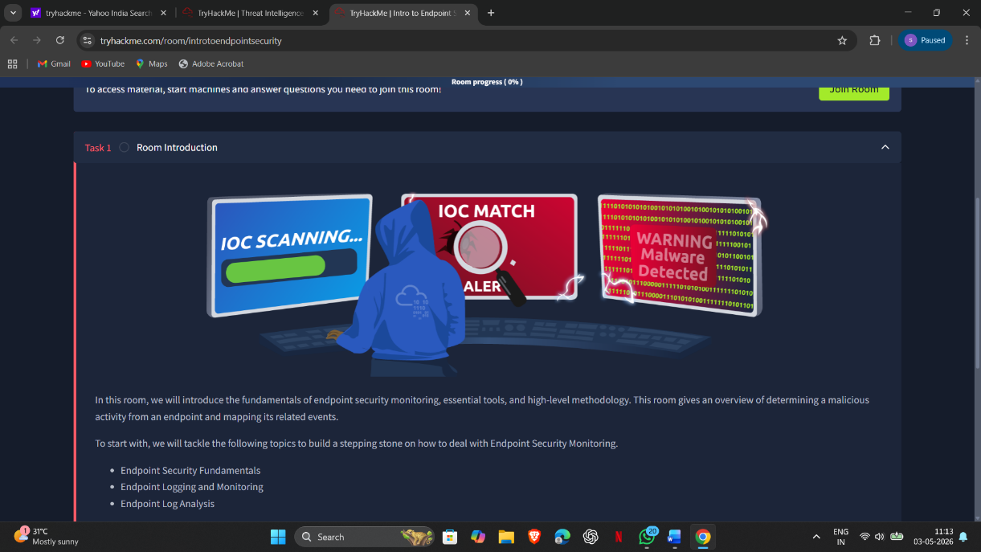

Task 2: Endpoint Security Fundamentals
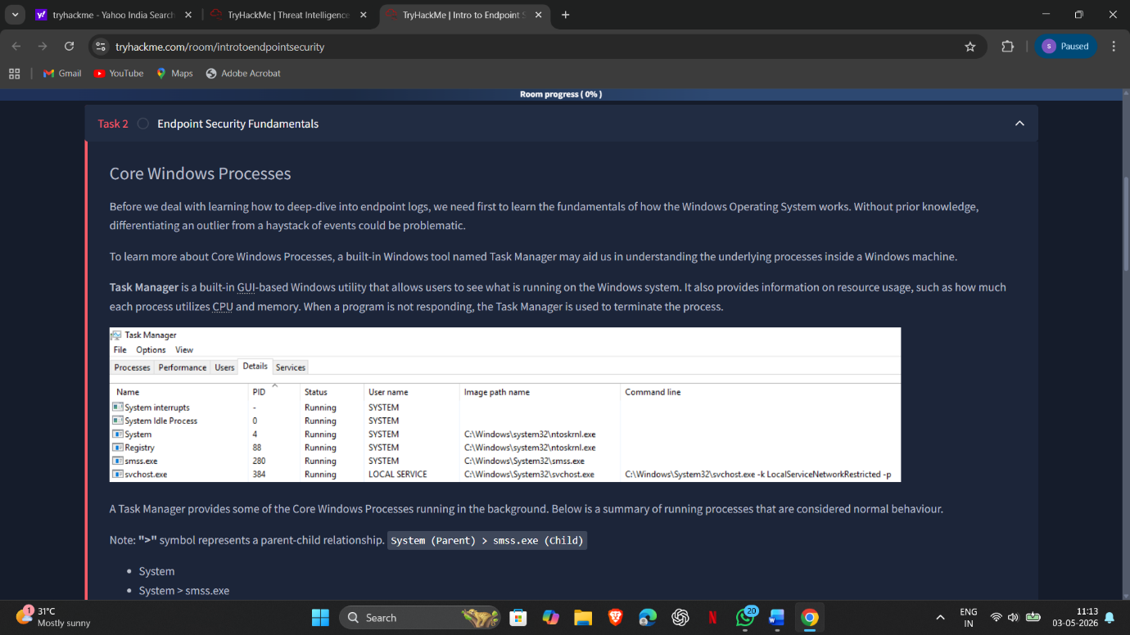
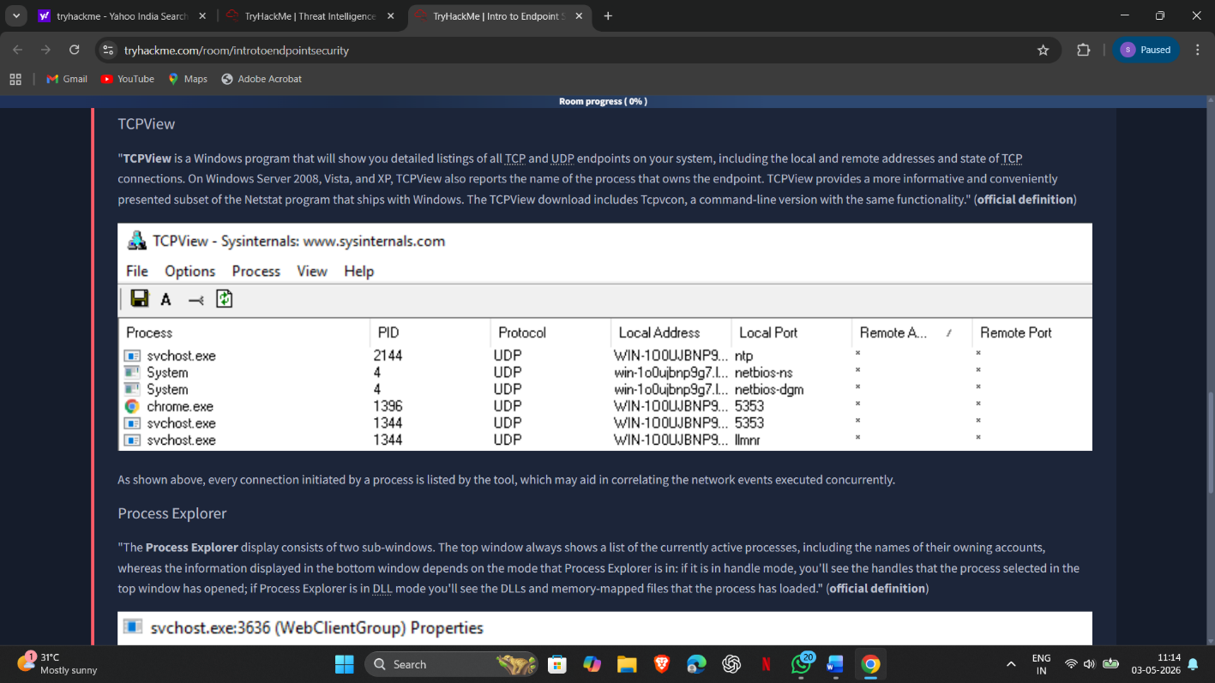

Task 3: Endpoint Logging and Monitoring
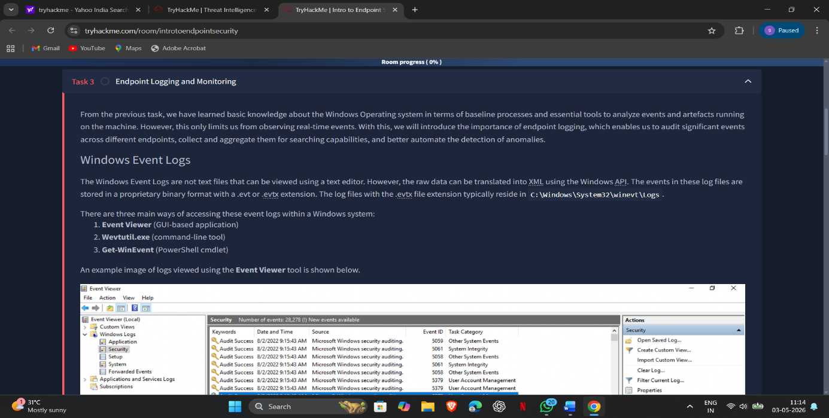
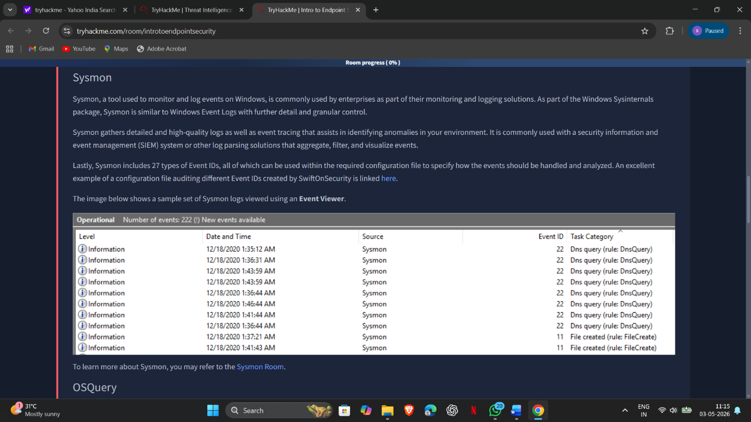
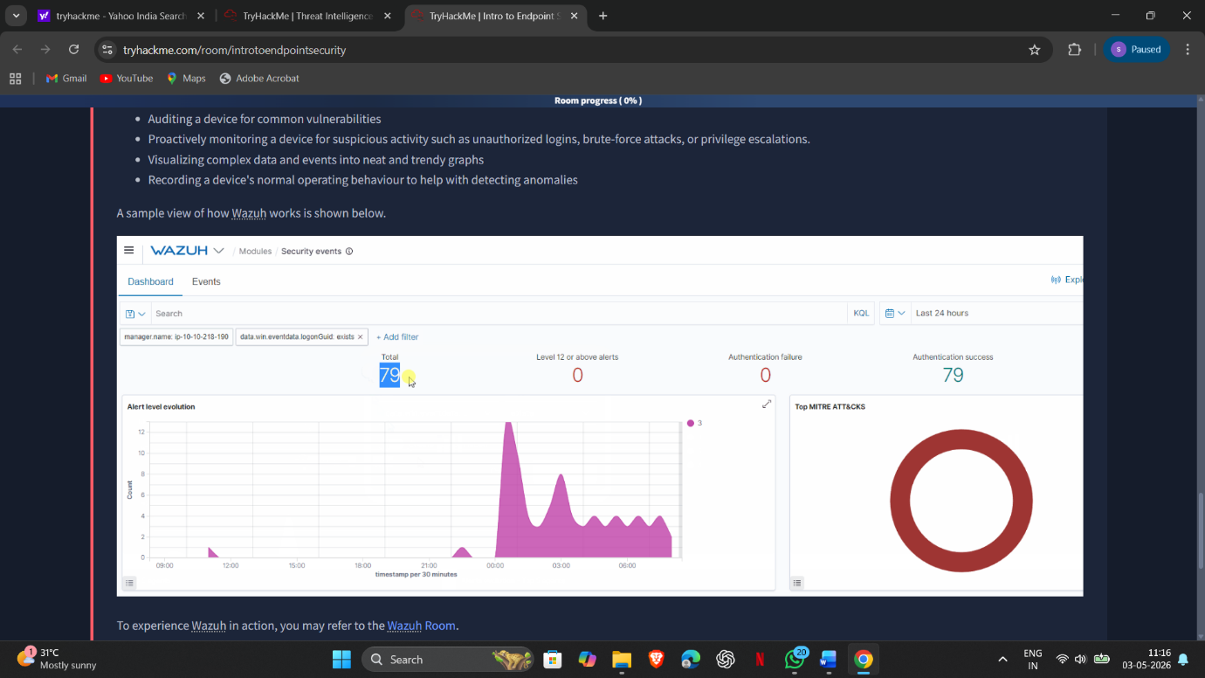

Task 4: Endpoint Log analysis
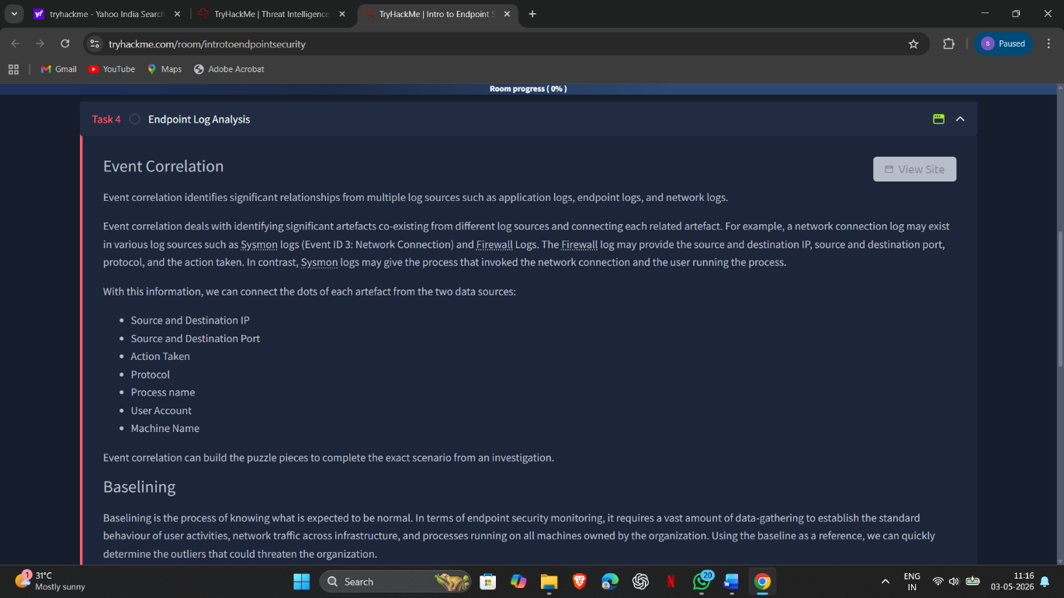
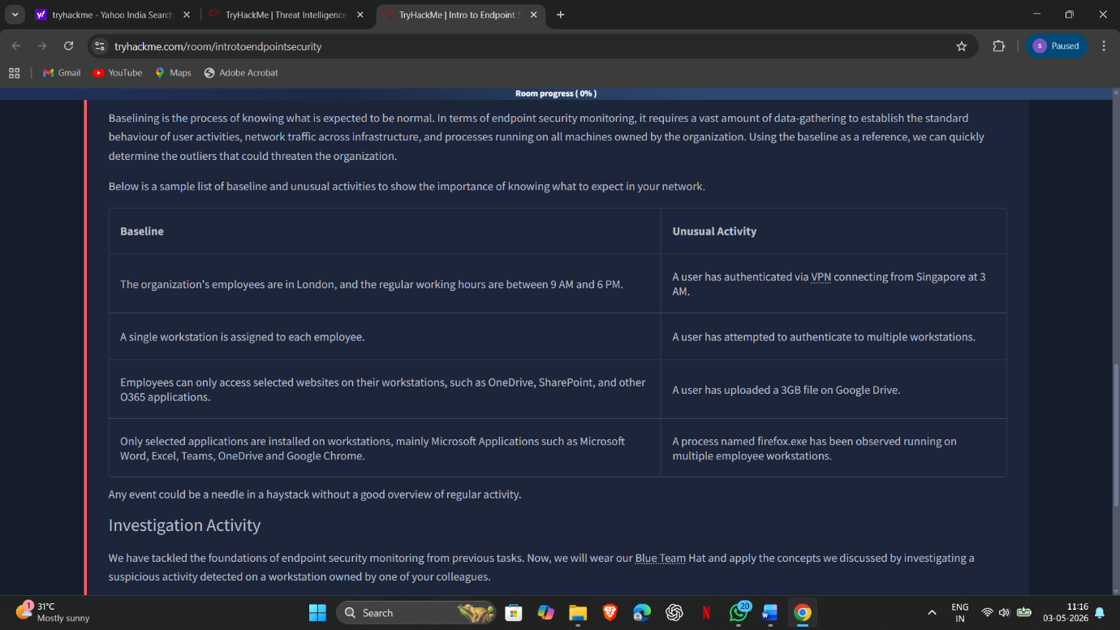

Result:
Successfully monitored and analyzed endpoint activities to detect potential threats. Gained practical knowledge of identifying malicious behavior, interpreting endpoint security alerts, and responding to incidents using endpoint security tools in a SOC environment.

